TRƯỜNG ĐẠI HỌC BÁCH KHOA
ĐẠI HỌC QUỐC GIA TP HỒ CHÍ MINH



HOMEWORK
MẠNG MÁY TÍNH (THỰC HÀNH) – LAB 5

Giảng viên hướng dẫn: Ths. Bùi Xuân Giang

Sinh viên thực hiện: Trần Minh Tân

Mã số sinh viên: 2012018

Lớp: L10.

Thành phố Hồ Chí Minh – 2022

PART I. ICMP and Ping.
This is the picture of my CMD
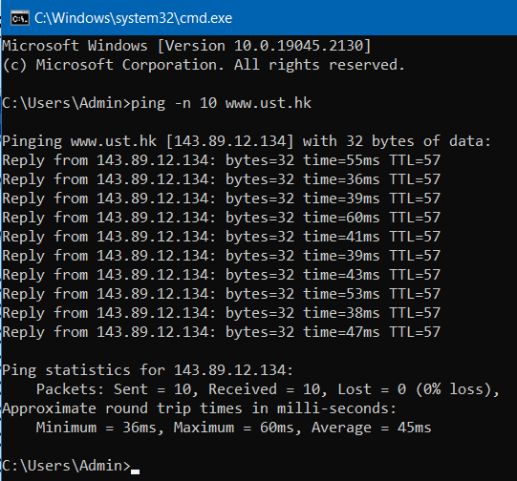
1. What is the IP address of your host? What is the IP address of the destination host?
The IP address of my host is 10.229.53.91. The destination host is 143.89.12.134
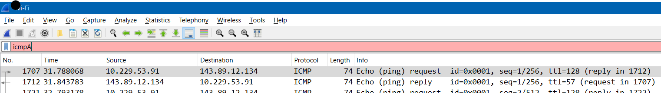
2. Why is it that an ICMP packet does not have source and destination port numbers?
TCP and UDP are transport protocols that use port numbers to multiplex their use between applications or processes. ICMP is not a transport protocol but a part of the IP protocol. It is used for signaling between hosts.
3. Examine one of the ping request packets sent by your host. What are the ICMP type and code numbers? What other fields does this ICMP packet have? How many bytes are the checksum, sequence number and identifier fields ?
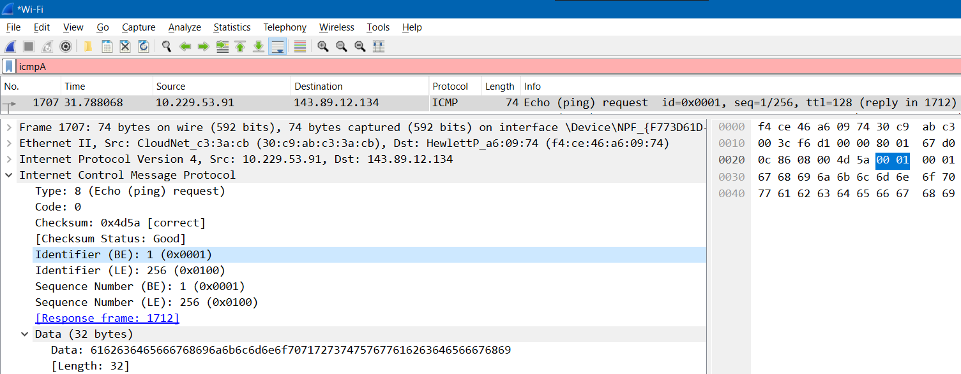
The ICMP type and code is 8 and 0 respectively.
The other fields are Checksum , Identifier and Sequence Number.
The checksum , sequence number and identifier fields are all 2 bytes.
4. Examine the corresponding ping reply packet. What are the ICMP type and code numbers? What other fields does this ICMP packet have? How many bytes are the checksum, sequence number and identifier fields?
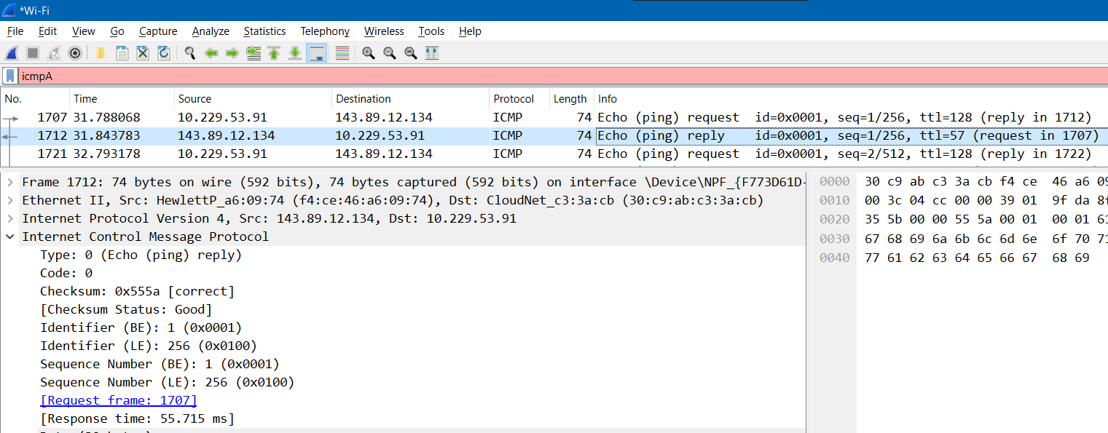
The ICMP type and code is 0 and 0 respectively.
The other fields are Checksum , Identifier and Sequence Number.
The checksum , sequence number and identifier fields are all 2 bytes.
PART 2. ICMP and Traceroute
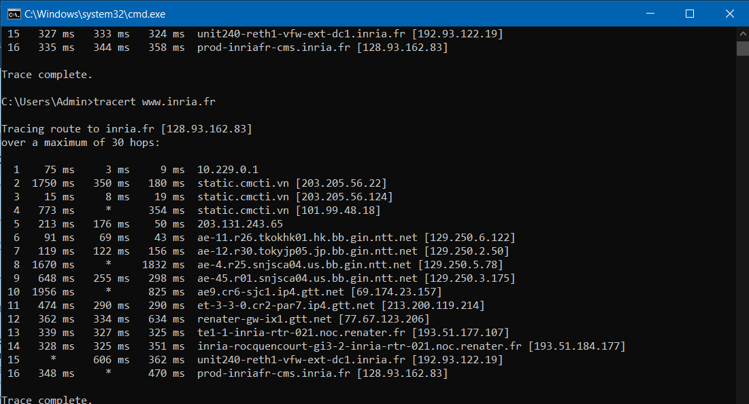
5. What is the IP address of your host? What is the IP address of the target destination host?
The IP address of my host is 10.229.53.91
What is the IP address of the target destination host ? 128.93.162.83
6. If ICMP sent UDP packets instead (as in Unix/Linux), would the IP protocol number still be 01 for the probe packets? If not, what would it be?
No, It would be 0x11.
7. Examine the ICMP echo packet in your screenshot. Is this different from the ICMP ping query packets in the first half of this lab? If yes, how so?
This is the ICMP ping query packet.
This is the ICMP echo packet in the second half of the lab
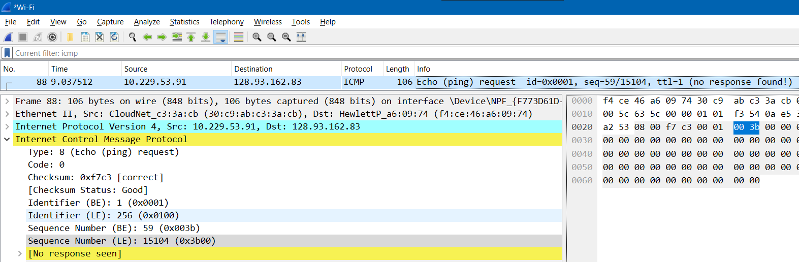
There are no different between them. The fields are the same.
8. Examine the ICMP error packet in your screenshot. It has more fields than the ICMP echo packet. What is included in those fields?
This is the screenshot of the ICMP error packet.
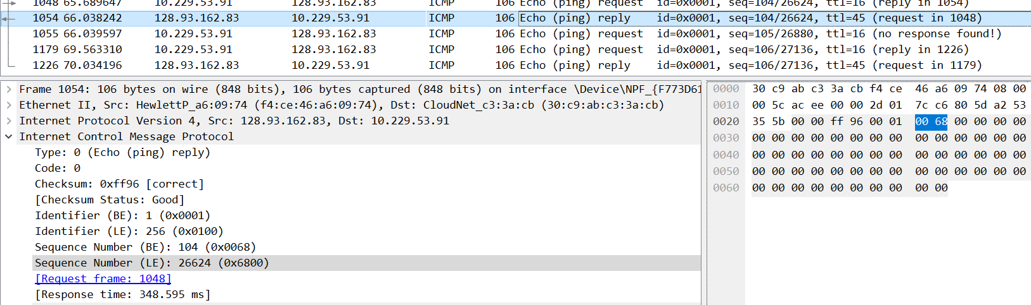
The fields included the information of the error packet as well as IPv4 fields.
9. Examine the last three ICMP packets received by the source host. How are these packets different from the ICMP error packets? Why are they different?
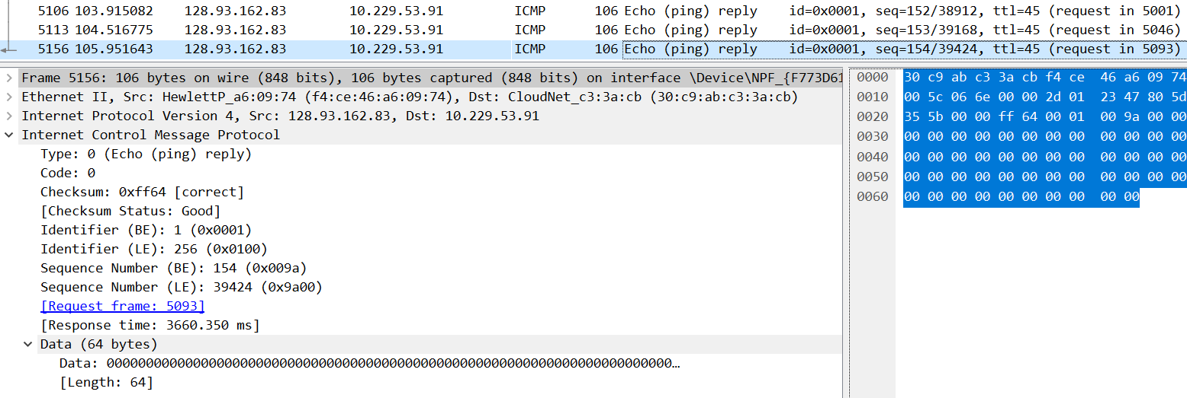
Thay are different from the ICMP error packets because they have the response time field and they don’t have the information of the error packet. Moreover, their type are 0, while the type of ICMP error packet is 8.
10. Within the tracert measurements, is there a link whose delay is significantly longer than others? Refer to the screenshot in Figure 4, is there a link whose delay is significantly longer than others? On the basis of the router names, can you guess the location of the two routers on the end of this link?
Yes, the link at 9 to 10 are the one whose delay is significantly longer than others.
The location of the two routers on the end of this link is New York City, base on the “nyc” in line 9.
